Colchester School District Staff,

Have you thought about who would make health care decisions for your if you were unable to do so yourself?
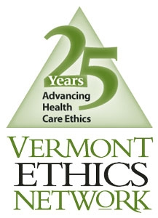
Join us for a presentation by the Vermont Ethics Network (VEN)
To discuss how medical decision-making works in Vermont and to learn about the tools available to you to document your health care decisions in advance. Unfortunately, illness, injury and accidents can happen at any time. How prepared are you?

CSD staff, friends and family are invited to join us for this free workshop:
Monday, January 23, 2012 at Porters Point School
You will leave this workshop with:
- An understanding of how medical decision-making works in Vermont
- Information about the available tools (Advance Directive Forms) for documenting your health care decisions
- A resource booklet to address future questions and additional forms to share with your family
Vermont Ethics Network
61 Elm Street
Montpelier, VT 05602
Tel: (802) 828-2909
www.vtethicsnetwork.org

Vermont Ethics Network is a local nonprofit working to provide resources to the community and health care providers on issues related to health care decision-making, health care ethics, palliative and end-of-life care.

